**CSCI 1411: Fundamentals of Computing**

**Lab 3**

**Due Date: 8:30 AM September 8, 2020**

**Name: Kerry Gip**

**Goals:**

* Use of variables of type int, double, float, char, string
* Use of operators +, -, /, *
* Understand integer and float operations

**Development Environment:** Hackerrank.com**;** IDLE

**Deliverables:**

1. This lab with 3 screen shots.
2. Your code for Part III. Name the file using the following format:

YourlastnameFirstnameLab03.py.

How to take a **screen shot**:

* For a Windows 10: Use Snipping Tool to copy and CTRL + V paste screen shot.
* For Mac: Shift + Command + 4 to copy and CTRL + V to paste screen shot.

**Part I – Hello World (5 points)**

* A great (and fun) way to practice Python is to challenge yourself to practice and competitions. There is a web site that allows you to do exactly that.
* Remember the ROCkET Methodology
  + **R**ead the entire problem, taking notes and underlining important areas
  + **O**utline the tasks in plain English with enough detail to write code
  + **C(k)**ode small portions at a time
  + **E**valuate each small portion of code. Ensure it compiles AND does what it is supposed to
  + **T**est the entire program. Ensure it compiles AND does everything listed in the outline
* Go to hackerrank.com, and set up a free account.
* Click on the Python 3 tile.
* Your first challenge should be to test out the hackerrank.com environment. You will type in following right after the #Hint statement:
  + return a+b
* Click the RUN CODE
* This should get you to the dashboard. Scroll down and click on the Python link

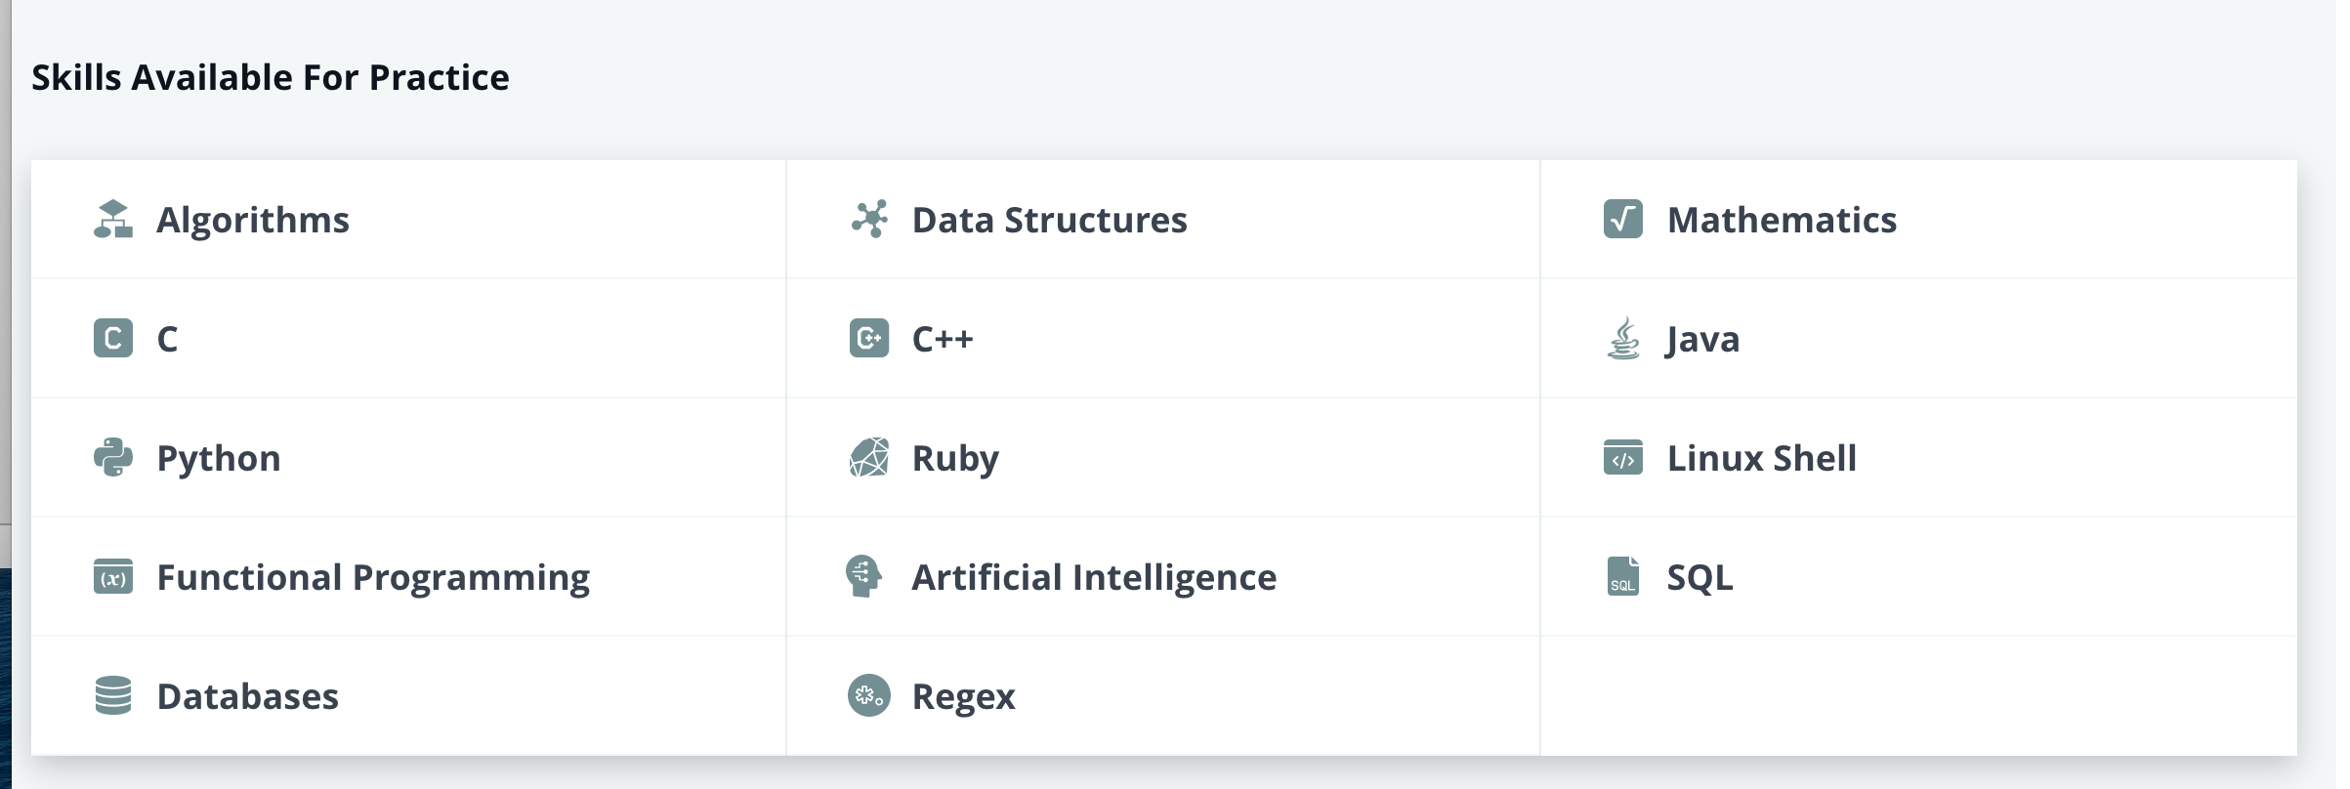

* Click the Continue Practice button.
* The very first challenge should be Hello World

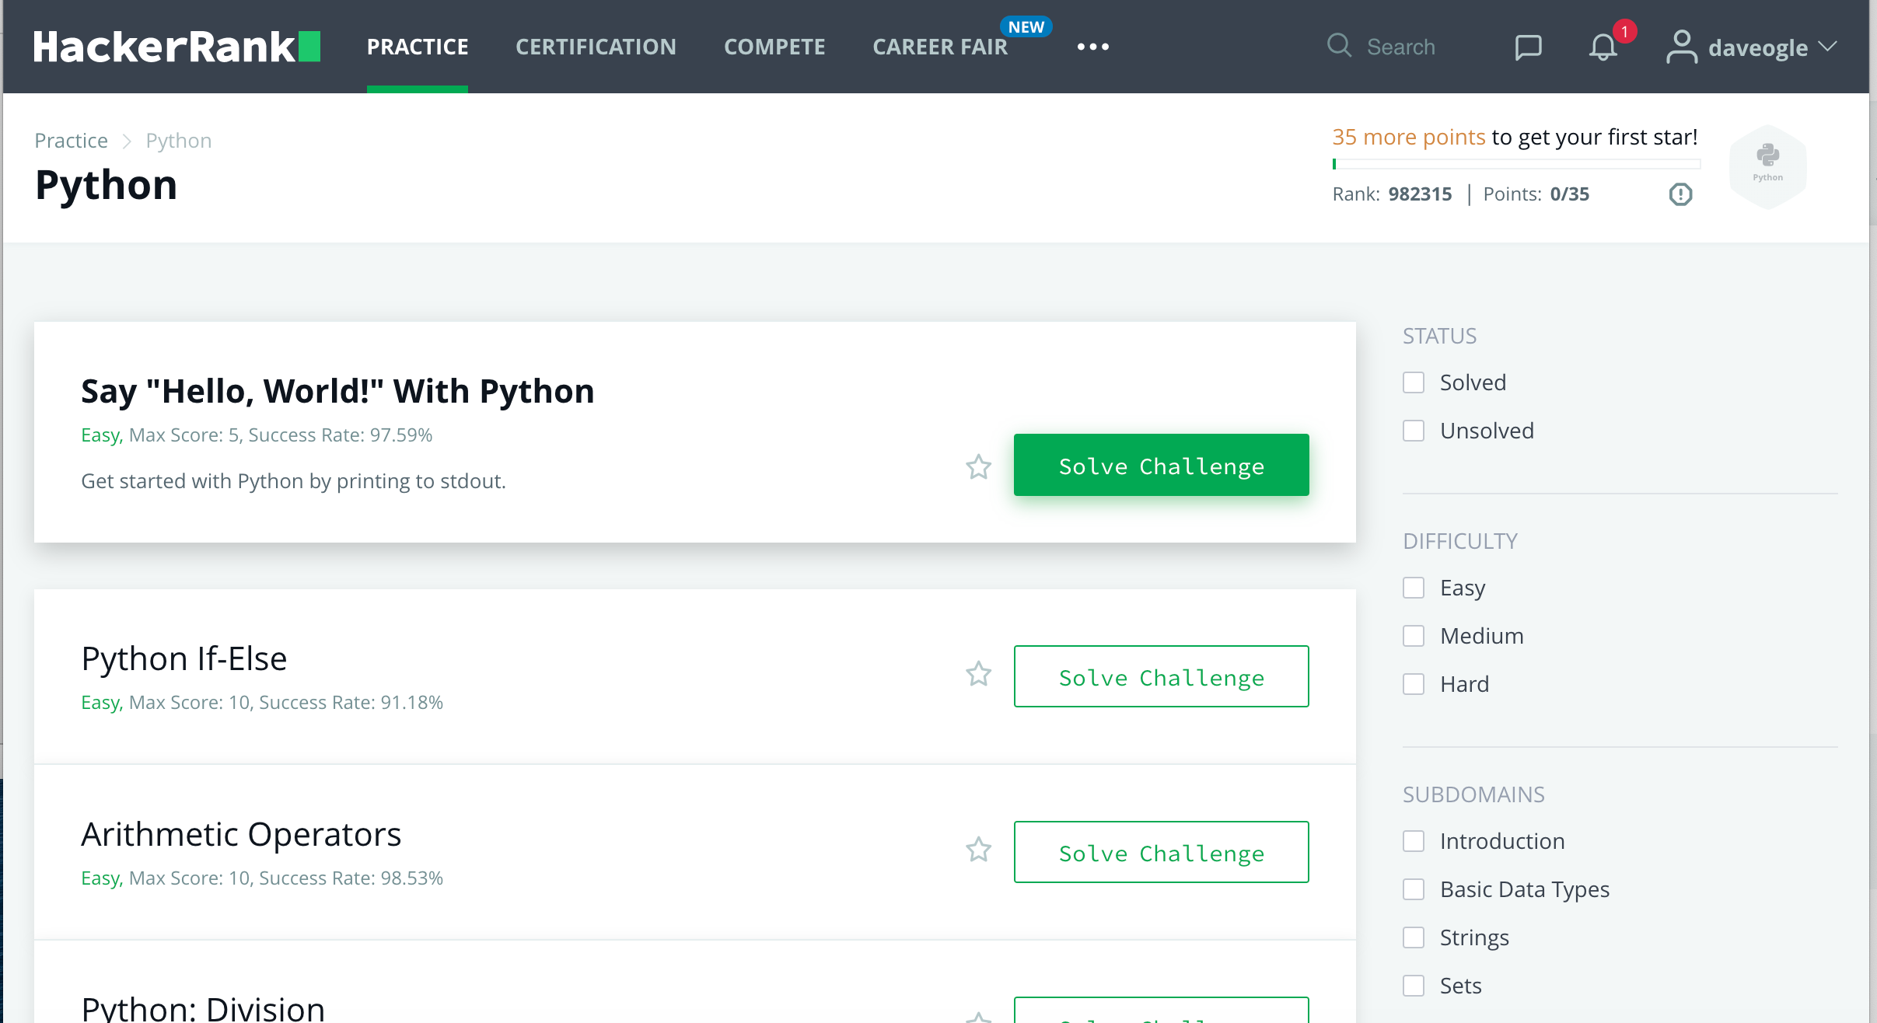

* Click on Solve Challenge next to Hello World and solve the problem!
* If there are any errors, then it will tell you where the error. If you run into issues, talk to your instructor who will give you some hints.
* **After you get success message, go to the submissions tab and take a screen shot showing that your lab was accepted and post it here.**

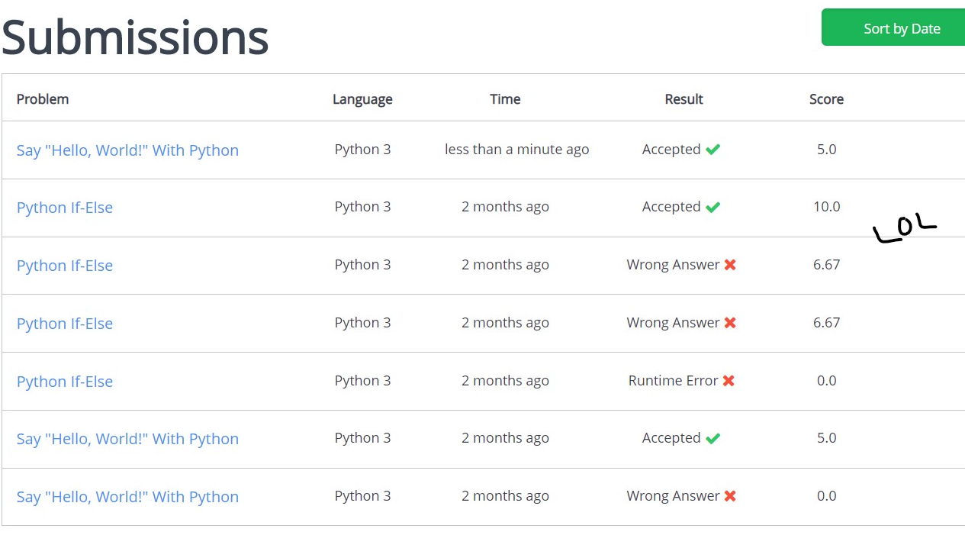

**Part II – Arithmetic Operators (10 points)**

* Complete the Arithmetic Operators challenge on hackerrank.com.
* Again, read the entire problem
* Fill in the code.
* Submit
* If you don’t get success message, work with your lab partner to see if you can get “Congratulations” message. After a “reasonable” amount of troubleshooting, ask your instructor for some hints.
* **After you get success message, go to the submissions tab and take a screen shot showing that your lab was accepted. Post that screenshot here**

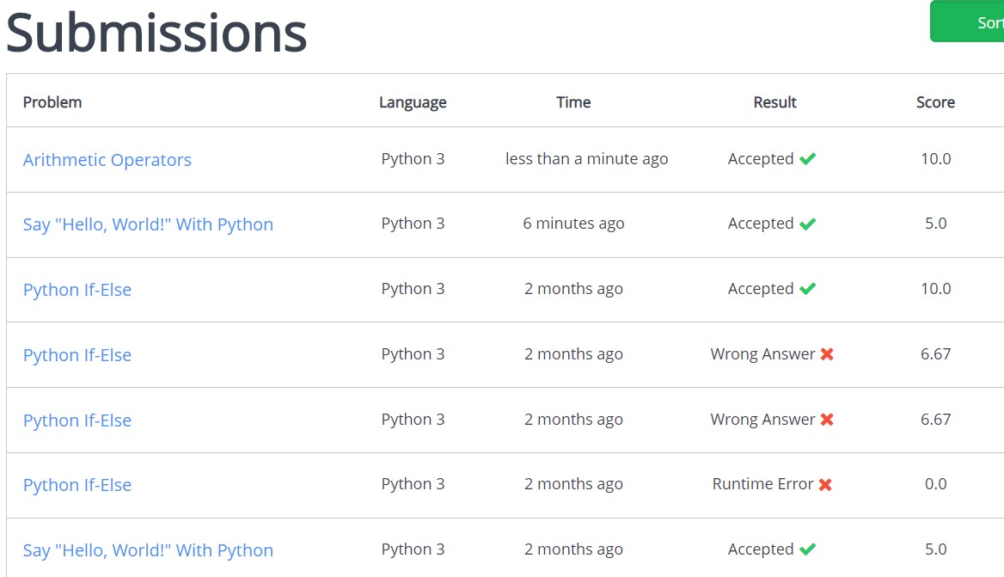

**Part III – Float versus Integer data types (10 points)**

In this part of the lab, we will be writing some code that demonstrates the difference between floating point division and integer division.

Problem statement:

* You have a **box** that has a length and width in inches. These lengths and widths are not restricted to be in whole numbers (e.g, the length could be 11.2 inches)
* You want to put trim around the box, but the local HW store only sells trim in 12” segments.
* A 12” segment of trim costs $1.88.

Create a program that does the following things:

* Ask the user the length, in inches, of the box
* Ask the user the width, in inches, of the box
* Calculates the perimeter of the box and prints that out (recall perimeter = 2*L + 2*W)
* Calculates and the number of segments needed to trim the box (go around the perimeter)
  + HINT: calculate 2 versions of this, one float, one int
  + Prints the int version of number of segments
* Calculates the cost of the trim (HINT: use the int version of the number of segments) and prints that out
* Calculate the amount of $$ you lost because you could not buy the trim in increments other than 12” segments (HINT: you will need to use the float number of segments and the int number of segments to calculate loss) and prints that out

The output should look something like this:

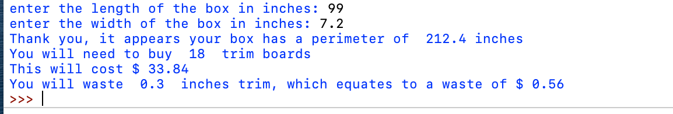

Every program should have the following comment block at the top. Make sure to fill in your name, lab partner’s name, class with section number, due date, brief description of your program, and status of your program:

*#*

*# Name:  
# Class: CSCI 1411-00X  
# Due Date:  
# Description:*

Run the module. Save the file using the format YourlastnameFirstnameLab03.py. For example, SmithSallyLab03.py (if your name is Sally Smith)

* **Capture a screenshot of your output and paste it here**

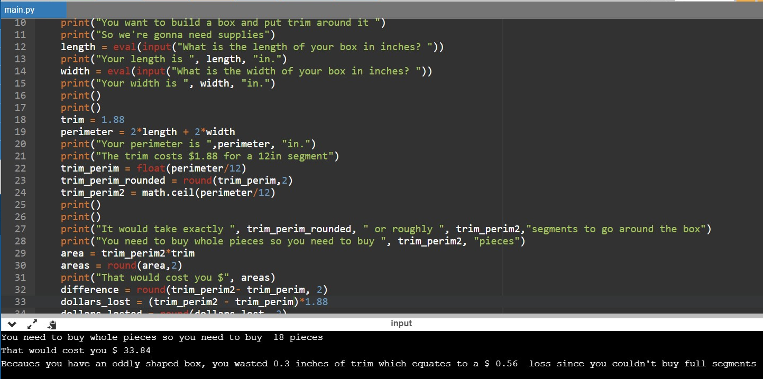

* **Submit your code on Canvas**